Chapter 9, Problem 49.

Find v_{s}(t) in the circuit of Fig. 9.56 if the current i_{x} through the 1-Ω resistor is
500 sin(200t) mA.

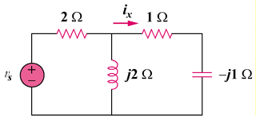

Figure 9.56
For Prob. 9.49.

